1a.

i) First I calculated X = ⅓ using X = C / T

Then I got V_p = X_p / X = 1

V_e = X_e / X = 100

U_p = B_p / T = 61.1%

U_e = B_e / T = 94.4%

S_p = B_p / C_p = 1.83s

S_e = B_e / C_e = 0.028s

D_p = V_p S_p = 1.83 s/job

D_e = V_e S_e = 2.8 s/job

ii) Bottleneck is device of max demand so here it is the compute engine (E).

Upper bound for throughput under heavy load = 1/Dmax = 1/(2.8) = 0.36

iii) Lower bound for avg waiting time under light load is D = Dp + De = 4.63

iv) De1 = 1.4 De2 = 1.4 and Dp = 1.83. The bottleneck device is now the preprocessor.

Upper bound for throughput under heavy load = 1/Dmax = 1/1.83 = 0.55

D stays unchanged so lower bound for avg waiting time doesn’t change

b

See tutorial sheet 3 question 5

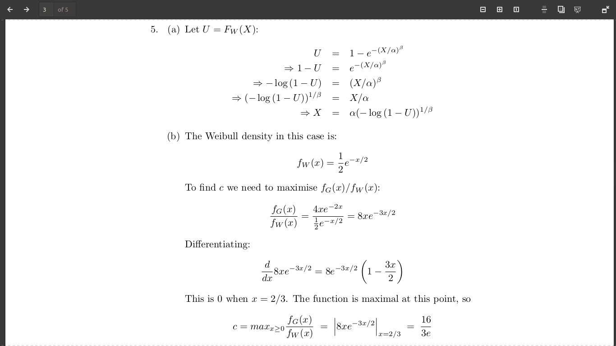

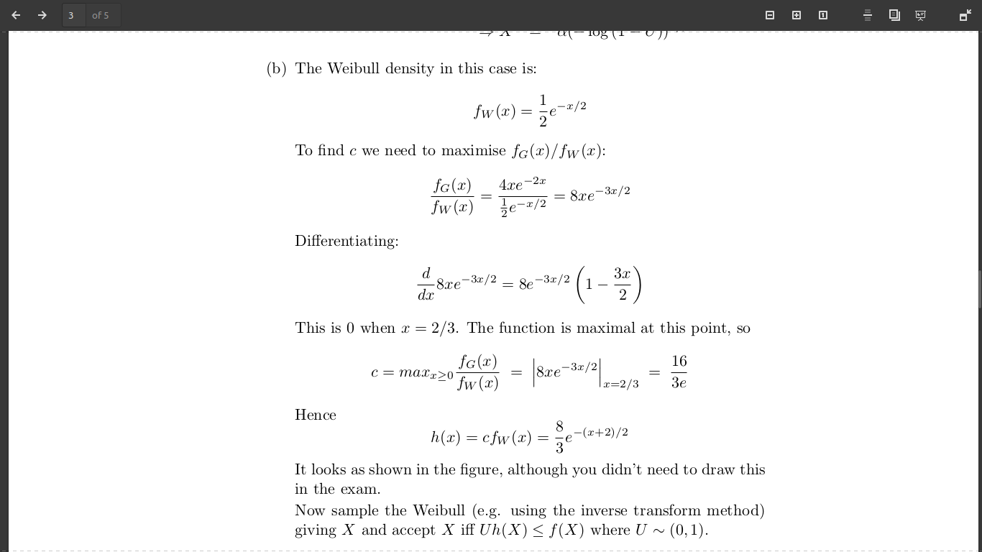

2

this is based on old coursework, omitted here

c)

nonCrit:

#non_crit--

if #crit == 0 and #queue == 0:

#crit++

schedule Crit at t + crit sample

else:

#queue++

Crit:

#executed++

#crit--

#non_crit++

schedule nonCrit at t + non-crit sample

if #queue > 0:

schedule Queue at t + sampleU(#queue)

Queue:

#queue--

#crit++

schedule Crit at t + crit sample

Init:

#queue = 0

#crit = 0

#non_crit = N

schedule N nonCrit's using the non-crit sample

3.

Lecture on 18 of November



b

Normally when we see the graph for opening queue network that means we need to list a traffic equation and solve it.

What we have is:

(\lambda_1, \lambda_2) = (2a \gamma, a \gamma) + [[1-q, q],[0,0]]

Solve the above we get

\lambda_1 = 2 a \gamma / q

\lambda_2 = 3 a \gamma

Then we calculate \rho and enforce the constraint that the \rho must be less than 1 which give us:

a < \mu / (3 \gamma)

a < q\mu / (2 \gamma)

Then we calculate the mean queue length by calculating the mean queue length in each node and then calculate the sum of the mean queue length for each node.

4.

Awhile

i) see slide

ii) see slide

iii) The expected response time is the expected value of the maximum of the inter-arrival times. This is equal to H_n / lambda, in this case H_3 / 2 = 11/12

b

don’t think this is covered anymore